RED BULL WINGS TEAM MEMBER ASSIGNMENT

Instructions:

Congratulations on making it this far! Now is your time to show your ability to handle real life situations related to the Connecticut Wings Team role. Complete the tasks and questions below to the best of your ability. If you crush it, you will move on to the final round of interviews!

Definitions to Know:

· **Mission:** A shift consisting of two Wings Team Members and one MINI Cooper. A shift is anywhere from 4 – 6 hours and will sample a minimum of 5 stops. The remainder will be improvised based on local market knowledge and nearby areas of interest.

· **Stop**: One of the many destinations or events that WTMs will sample at during a mission. Stops are organized by sampling occasion,

· **Sampling Occasion:** a designated category of activities that need Wings the most. Examples: At Work, Fitness, Study, Sports, Leisure, , Party, Gaming

· **WTM:** Wings Team Member

· **On-Premise Sales Support:** accounts that sell Red Bull to consumers who will most likely be drinking it on-site ex: bars, restaurants, etc

· **Off-Premise Sales Support:** accounts that sell Red Bull to consumers who will most likely not be drinking it on-site ex: gas stations, Target, Publix, Costco

· **Non-Traditional Sales Support:** Red Bull sold in cafeterias, vending machines, office coolers, etc.

· **Sampling:** The act of engaging with the consumer in a premium manner while delivering a benefit message about Red Bull and of course, a cold can!

· A great WTM is an expert of juggling the knowledge of our goals, our territory, and our consumer and connecting the dots to sample the right person, at the right place, at a time when they need energy most!

· **Red Bull TV:** If Netflix, YouTube, and Red Bull had a baby… it is Red Bull TV. On demand video content from around the world that inspires people to follow their passions. Check it out on AppleTV, on your smart phone, or on<http://www.redbull.tv>

· Red Bull is traditionally seen as a party mixer or an action sports drink. The goal of the Wings Team is to open peoples’ minds to the possibilities of Red Bull’s effectiveness, suggest a new consumption occasion educate the consumer on the ingredients when asked, and grow our presence in Connecticut. We are also here to support our on and off premise sales teams. Red Bull is a premium product and brand and our Wings Team reflects that brand, makes it tangible to the public, and provides an opportunity to bring our awesome brand to life!

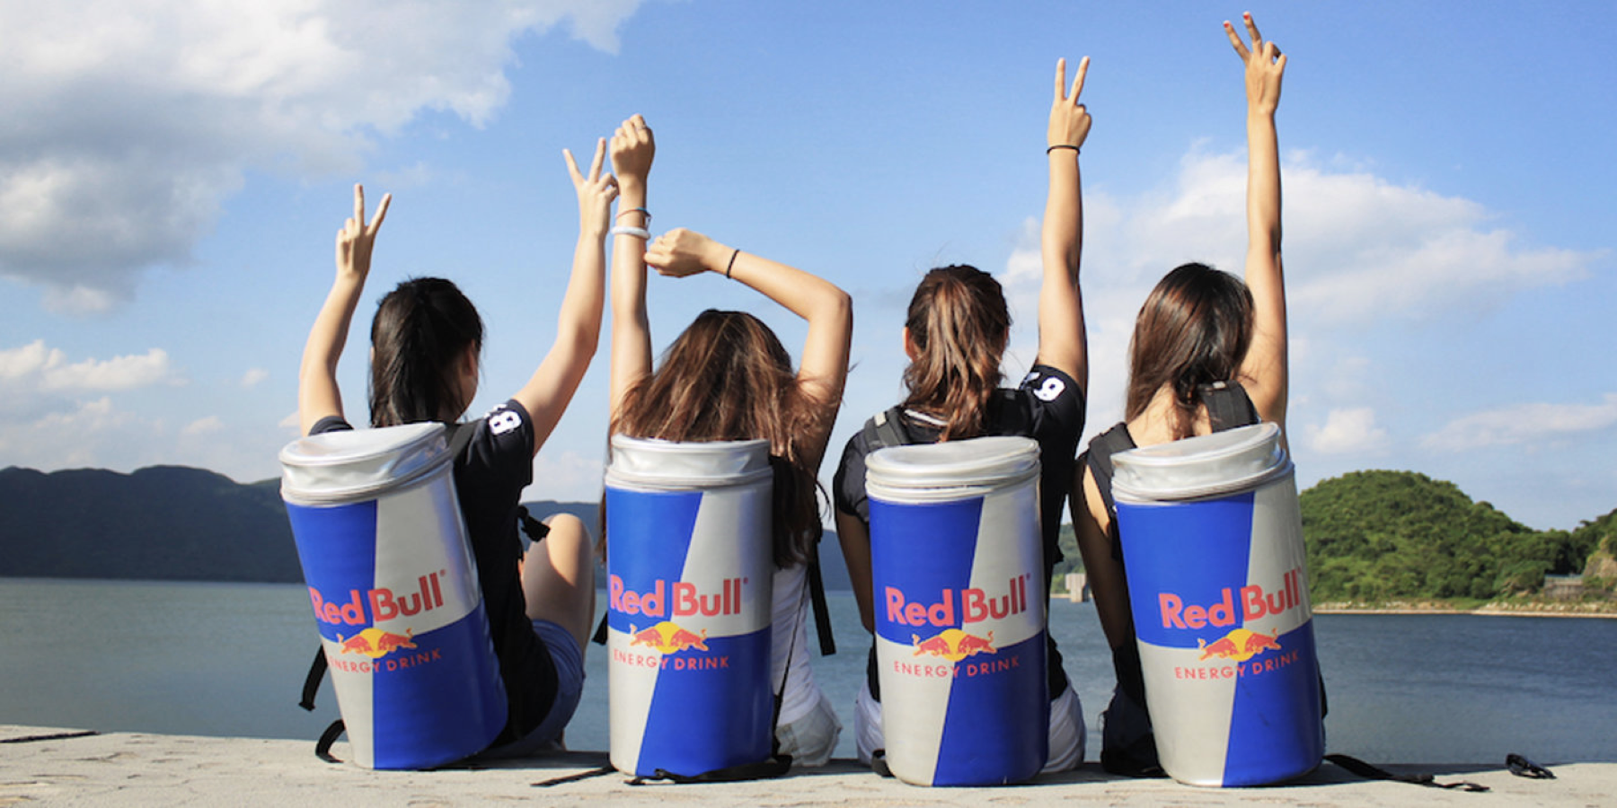

1. The following scenes are current focuses for our field marketing team. Build out 2 solid mission plans from the options below. Take it seriously; we may put this into practice!

· **At-Work:** We spend the majority of our time working and it would be a huge success to have Red Bull associated with performance increases in the work place. Let’s find some big offices, corporate headquarters, industrial plazas, and improve their day! We all have jobs, and we all need energy. Where would you sample for the At Work occasion to boost somebody’s day who’s never had a Red Bull?

· **Video games** are a rapidly expanding market as well. Red Bull even sponsors e-sports athletes to compete on the world stage! Gamers drink a lot of Red Bull to improve hand eye coordination, fast reaction time, and to stay alert during long nights. They may be a more introverted consumer, but we have to pay attention to what’s rapidly gaining popularity so we can stay ahead of the curve and help innovate. This can be video game stores, events, and organizations. Get creative!

· **Women.** Red Bull is traditionally a very male oriented company. But, that is about to change. We are increasing our relevancy to the female population by pursuing more feminine marketing tactics. Where would you sample Red Bull to target the female community, and why?

· **Gen Z.** This is the generation following millenials. You can also think of them as young college students, but keep in mind only about half of them attend college. They are very tech savvy, and live immersed in a digital world. They are ages 14-21 but we can only focus on people 18 and up as a federal law. Where would you go to sample to appeal to Gen Z ages 18-21, and why?

As you can see, our marketing strategy is based off of growth, innovation, and an awareness of what’s trending around us. Use your knowledge and research to build out 1 mission around the consumption occasions of your choice. Keep in mind, we have a full team planning 2-3 missions per day, so there isn’t much that we haven’t done. Show me that you have what it takes to be able to think strategically and find new and unique ways to appeal to these target markets.

2. Finding new consumers is the goal that continues to drive Red Bull into new territories, seeking out those people who have never tried a Red Bull. Keeping in mind that our target demographic is 18-40 year olds, make a list of scenes, sports, music genres, trends, areas, or ANYTHING that would help finding NEW CONSUMERS. **People who have rarely or never tried a Red Bull.** I know it’s hard for you to do this without knowing what we already do, but the goal is for you to show that you can think creatively. What’s the next big thing that we should be involved with. Give 3 ideas or examples.

1. Xfinity Center in Hartford for concerts/tailgates

* Before entering into a concert, college students mainly tailgate outside the xfinity theatre, only costs $10-15 to park, but with the livelihood of people gathering together to party, before going into the theatre and buying overprice drinks, it’s a fun time out there.
* Targeting this will promote good energy at these events

Events:

1. Sail Fest, New London, CT – Summer usually after 4th of July

* 3 day festival in the summer, nice and warm
* Culminates 300,000 people from all over CT and visitors outside as well; age ranges from kids to families, obviously pinpointing those who are ready to have a fun night prior to the fireworks
* Place cans on the pier or hand them out in downtown along with all the other street vendors
* Main street is closed down for pedestrians, bars and clubs open at night, but we will deliver outside on the street prior to entry or just for the passerby

1. New England ChowdaFest, Westport, CT

* Most people I’ve talked to love clam chowder, especially if they are from new England
* It’s got a good name and a diverse group of people ranging from ages 18-40 years old. Pictured on the website, you can see a large group of chowder tasters, as they do look on the older side. Why not wash down some clam chowder and rejuvinate your taste buds to try some other chowder as well?

3. Red Bull is a leader in social media and is always looking for new ideas on how to activate around these platforms.

· What are 3+ examples of ways Red Bull can use digital media platforms to promote events and products. Think outside the realm of Snapchat filters/lens or Facebook groups.

· Give 5+ examples of “instafamous” people that are local to Connecticut.(5k+ followers) Can be friends, family, classmates. Bonus points if they are related to gaming, female, or fitness. Why do you think they have such a strong following?

1. Handle: @jaimsoup

Following: 78.8k

Explanation: Her Instagram is a personal blog, as does everyone, and is already an ambassador for a women’s clothing line. She’s based in Connecticut and would probably do a sponsored promotion with RedBull.

2. Handle: @erinrossxo

Following: 56.2k

Explanation: She attends PC and has her own website, which sponsors fitness and good health while promoting herself and her brand. She has a twin.

3. Handle: @erikarossox

Following: 31.2k

Explanation: Also attends PC, shares the website with her sister. Posts pictures about being body positive while working out.

4. Handle: @

Following:

Explanation:

5. Handle: @

Following:

Explanation:

· Give 5+ examples of people who are influential on campus and why. They can be party promoters, media, club leaders, the movers and shakers. We want to be well connected and we hope you may be able to help us do so!

1. Berkley Gillan – ambassador for This is College – it’s a party promotion to events at bars and club as well as house parties
2. S
3. S
4. S
5. S

4. Our team is constantly expanding, making recruitment a huge priority! Where would you look to recruit Wings Team Members? What qualities would you prioritize?

5. The Wings Team has recently become strongly sales-driven. We are constantly looking for opportunities where we can directly influence sales. Think of an opportunity to make a huge impact on Red Bull sales. Briefly describe 3 ideas that support our sales initiative. Examples: vending machines in large office cafeterias, new accounts that don’t carry Red Bull but should, unique product displays in stores, or amazon dash buttons.

5. Checkout these brand traits below. Which three brand traits do you resonate with the most? Why?

1. Individual

1. Creative

1. Love Life

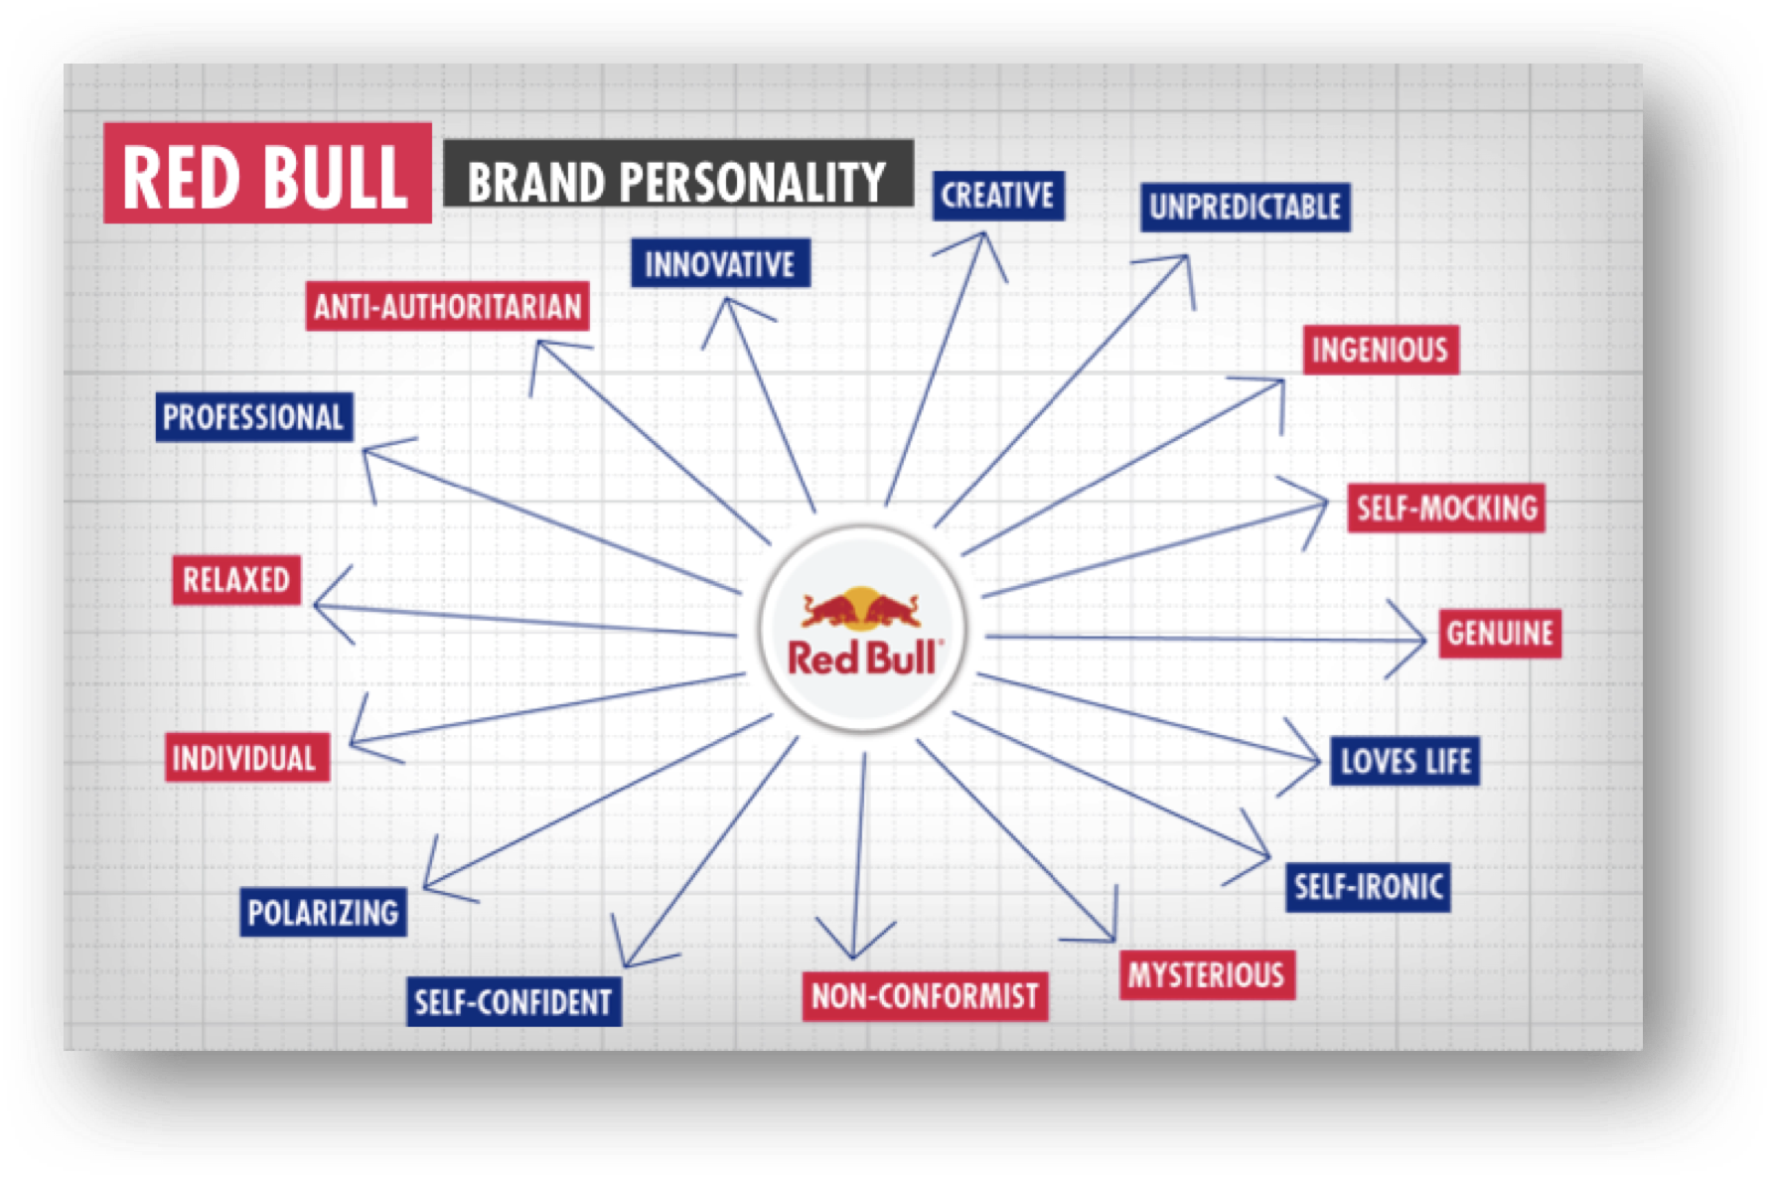

Good Luck!

- Zack

Where to implement red bulls on campus

* NEVER say a bar – because they sell them there; would infringe on sales
* SAY a school event – dance, club competition, sports competition (home games), rugby
  + Also part of the business school club, administer cans around the business school
  + Bumble does something similar at our school donating cookies to get people to download their app and promoting with stickers placed around tables